

Participant Communication Kit
Age-Friendly Health Systems



Contents
Welcome to the Age-Friendly Health Systems Movement 3
About Age-Friendly Health Systems 3
How to Use This Kit 4
Key Messages 5
Types of Communication 6
Spread the Word with a Press Release 6
Feature in Your Newsletter 7
Tell Stories in a Blog Post 7
Share on Social Media 8
Display Your Commitment with a Badge 9
Use the Logo 10
Celebrate with Your Team 10
Brand Guidelines 11
Written Style 11
Descriptive Statement 11
4MS Framework 12



Welcome to the Age-Friendly Health Systems Movement
Congratulations! You are part of a rapidly growing movement of Age-Friendly Health Systems (AFHS). Our founding partners — The John A. Hartford Foundation, Institute for Healthcare Improvement, American Hospital Association, and Catholic Health Association of the United States — applaud your hard work. This is an exciting movement and there is much to be proud of as, together, we improve the health and health care of older adults.
Recognition requires working toward reliable practice of a set of four evidence-based elements of high-quality care for all older adults, known as the 4Ms: What Matters, Medication, Mentation, and Mobility. As a Participant (Level 1) team, you have successfully developed plans to implement the 4Ms.​
To help your system talk about its involvement in the initiative and to raise awareness of the broader Age-Friendly Health Systems movement within your community, we've compiled a suite of communications materials which can be customized to your organization. We encourage you to spread the word about your involvement in the Age-Friendly Health Systems initiative through your various communications platforms and channels.
For hospitals, the CMS Age Friendly Hospital Measure advances the AFHS movement’s vision to ensure that all older adults receive age-friendly care that is evidence-based and aligns with what matters most to the older adult and their family caregivers. See more resources for how to act on both the CMS Measure and the 4Ms.
If you have any questions along the way, please email afhs@ihi.org. We also invite you to connect with peer organizations through the Age-Friendly Health Systems Online Community. Thank you!

About Age-Friendly Health Systems
In 2017, The John A. Hartford Foundation (JAHF) and the Institute for Healthcare Improvement (IHI), in partnership with the American Hospital Association (AHA) and the Catholic Health Association of the United States (CHA), set a bold vision to build a social movement so that all care with older adults is age-friendly care.
A team of experts reviewed evidence-based care models. Then, pioneer health systems worked with IHI to conduct pilot testing.
The 4Ms Framework for Age-Friendly Care that emerged is both evidence-based and able to be put into practice reliably in health care settings. An Age-Friendly Health System is one in which every older adult’s care:
- Is guided by an essential set of evidence-based practices (the 4Ms);
- Causes no harms; and
- Is consistent with What Matters to the older adult and their family.
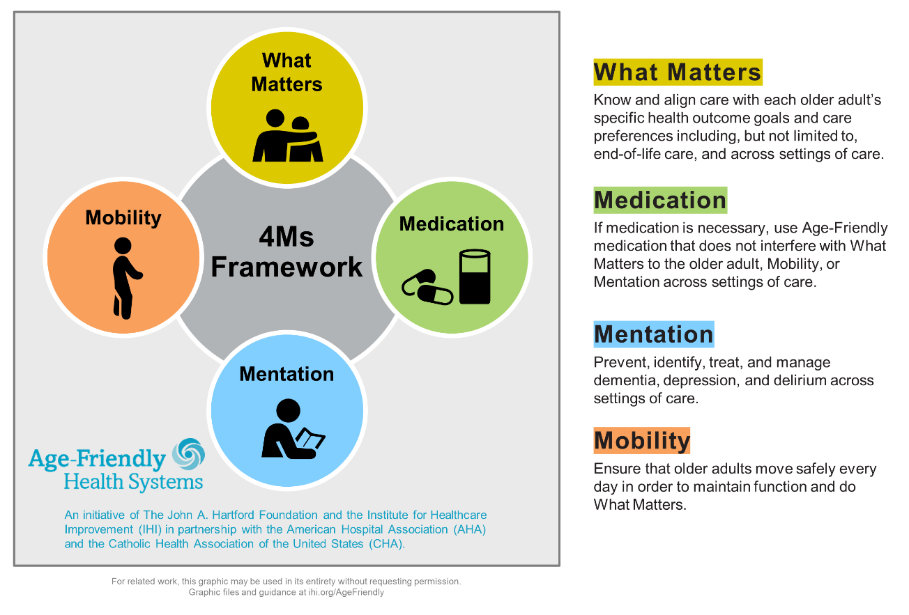
To find the latest resources and opportunities to engage with the movement, please visit www.ihi.org/AgeFriendly.

How to Use This Kit
This kit includes key messages to share about your work in the Age-Friendly Health Systems movement. You’ll find guidance and examples for sharing the results of your continued hard work in different formats, including social media posts, blog posts, newsletters, a press release, a badge, and celebrations within and beyond your organization.
Feel free to jump around and begin with the format that works best for you and your team. Try to start with one post, one time, and go from there!
We encourage you to review the brand guidelines on page 11 to promote consistent language and style when all of us talk about the Age-Friendly Health Systems movement. In addition, please be sure to align with your organization’s requirements for sharing. Consult with your marketing/communications team, if applicable.
As you go, consider:
- Who do you want to reach, and why? How can you make sure to include people who represent the range of diversity in your community?
- What information or feeling do you want to convey? (Hint: Review the key messages on page 5.)
- When and how will you share? (We encourage you to start small and build from there!)
Thank you for all that you do and for being part of growing the Age-Friendly Health Systems movement.

Key Messages
[Everyone deserves age-friendly health care]
All older adults deserve safe, high-quality health care that is based on what matters most to them as individuals and delivered reliably in every setting.
[We are making it happen]
[NAME OF ORGANIZATION] is leading the way in making sure that every day, every older adult receives age-friendly health care.
[We are using the 4Ms as our framework]
As part of the Age-Friendly Health Systems movement, we are leaders in a movement to implement age-friendly health care across the country and worldwide.
The four essential elements of an Age-Friendly Health System are known as the 4Ms:
- What Matters: Know and align care with each older adult's specific health outcome goals and care preferences in​clu​ding, but not limited to, end-of-life care, and across settings of care.
- Medication: If medication is necessary, use Age-Friendly medications that do not interfere with What Matters to the older adult, Mobility, or Mentation across settings of care.
- Mentation: Prevent, identify, treat, and manage dementia, depression, and delirium across settings of care.​
- Mobility: Ensure that older adults move safely every day in order to maintain function and do What Matters.
[Partner with us!]
Together we will continue improving the care of older adults and, in doing so, make lasting change in our communities. For more information, visit [ADD LINK to organization web page about age-friendly care] or see www.ihi.org/AgeFriendly to learn about the movement.

Types of Communication

Spread the Word with a Press Release
Adapt the template below to fit your organization and audience:
[NAME OF ORGANIZATION] PARTICIPATES IN NATIONAL AGE-FRIENDLY HEALTH SYSTEMS INITIATIVE
[NAME OF ORGANIZATION] announced today that it is part of a movement to improve health care for older adults, contributing to a goal of continuing to expand and grow age-friendly care.
As part of the Age-Friendly Health Systems initiative, The John A. Hartford Foundation and the Institute for Healthcare Improvement, in partnership with the American Hospital Association and the Catholic Health Association of the United States,​ are helping health care organizations implement a set of evidence-based interventions specifically designed to improve care for older adults.
Collaborative learning opportunities across the movement bring together health care teams committed to sharing data and improving together. All teams strive toward reliably implementing age-friendly best practices across hospitals, clinics, nursing homes, home health agencies and primary and specialty care settings.
[NAME OF ORGANIZATION] now joins an international group of more than 5,200 health systems working to tailor care to patients’ goals and preferences and to deliver care that is consistently of the highest quality.
“[ORGANIZATION] has always been on the forefront of patient care, and that’s why we are participating in this vital movement. We look forward to both sharing our best practices and learning what’s working for others providing age-friendly care,” said [NAME], [TITLE] of [ORGANIZATION]. “The Age-Friendly Health Systems initiative is an important part of our overarching vision to provide every older adult with the best care possible.”
The initiative is based on a series of practices focused on addressing four essential elements of care for older patients:
- What Matters: Know and align care with each older adult’s specific health outcome goals and care preferences in​clu​ding, but not limited to, end-of-life care, and across settings of care.
- Medication: If medication is necessary, use age-friendly medications that do not interfere with What Matters to the older adult, Mobility, or Mentation across settings of care.
- Mentation: Prevent, identify, treat, and manage dementia, depression, and delirium across settings of care.​
- Mobility: Ensure that older adults move safely every day in order to maintain function and do What Matters.
Age-Friendly Health Systems is an initiative of The John A. Hartford Foundation and the Institute for Healthcare Improvement (IHI), in partnership with the American Hospital Association (AHA) and the Catholic Health Association of the US (CHA). For more information, visit www.ihi.org/agefriendly.
Feature in Your Newsletter
Adapt the writing depending on the audience of your newsletter.
[ORGANIZATION] Recognized for Participation in National Movement to Improve Care for Older Adults
[NAME OF ORGANIZATION] is participating in Age-Friendly Health Systems, an initiative of The John A. Hartford Foundation and the Institute for Healthcare Improvement, in partnership with the American Hospital Association and the Catholic Health Association of the United States. As part of the initiative, [ORGANIZATION] is implementing a set of evidence-based interventions designed to improve care for older patients known as the “4Ms” – What Matters, Medication, Mentation, and Mobility. See ihi.org/AgeFriendly to learn more.

Tell Stories in a Blog Post
A blog post (or a short video) is a great way to get the word out to your community about the impact of the 4Ms and age-friendly care on people’s health care and on their lives, through the transformative power of sharing stories. See below for sample language to get you started.
Age-Friendly Health Care: What Patients Need and Deserve
Older adults are living and working longer, redefining later life, and enriching our communities. The future of health care requires bold approaches that value older adults, address their unique needs, and provide them with the best care possible. Improving the way we care for older adults also makes good business sense for hospitals and health systems: Delivering better care to older adults in every setting can help us achieve fewer avoidable hospital readmissions, better outcomes, more satisfied patients and families, and lower overall costs.
This is why [NAME OF ORGANIZATION] has joined Age-Friendly Health Systems, an initiative led by The John A. Hartford Foundation and the Institute for Healthcare Improvement in partnership with the American Hospital Association and the Catholic Health Association of the United States.​ It’s a movement to deliver safe, reliable, high-quality health care in every setting based on what matters most to older adults as individuals (see ihi.org/AgeFriendly).
As part of the Age-Friendly Health Systems Action Community, [ORGANIZATION] is testing and implementing a set of evidence-based interventions proven as the essential initial elements needed to provide older patients better care. We call them the “4Ms”:
- What Matters: Know and align care with each older adult’s specific health outcome goals and care preferences in​clu​ding, but not limited to, end-of-life care, and across settings of care.
- Medication: If medication is necessary, use age-friendly medication that do not interfere with What Matters to the older adult, Mobility, or Mentation across settings of care.
- Mentation: Prevent, identify, treat, and manage dementia, depression, and delirium across settings of care.​
- Mobility: Ensure that older adults move safely every day in order to maintain function and do What Matters.
[CUSTOMIZE THIS SECTION WITH EXAMPLES OF 4Ms YOUR ORGANIZATION IS TESTING AND/OR A QUOTE FROM A PATIENT AND/OR FAMILY MEMBER]
It is our hope that as we implement and refine our processes, we’ll be able to provide more older adults with the care that they want, need, and deserve. If you are interested in becoming part of the movement, please go to ihi.org/AgeFriendly.
Tip: For photos or illustrations, consider the message you are sending. Choose images of people with pleasant or happy expressions. Include representation of different body types and abilities. Avoid stereotypes or cliches, like older adults watching a sunset.

Share on Social Media
Adapt these sample posts to use on your preferred social media platform(s).
Include the following hashtags and organizations in each post if space permits; otherwise, include them in a reply or comment below each post:
Hashtags: #AgeFriendlyHealthSystems #olderadults
Organizations: @TheIHI (Institute for Healthcare Improvement) @JohnAHartford (The John A. Hartford Foundation) @ahahospitals (American Hospital Association) @TheCHAUSA (Catholic Health Association of the US)

Text: We’ve joined a nationwide movement to improve care for #olderadults. Learn how we’re creating #AgeFriendlyHealthSystems with @TheIHI @JohnAHartford @ahahospitals @TheCHAUSA Read more: [Add link]
Image: Participant Badge image (see page 9)
Text: #Olderadults deserve high-value, evidence-based health care that treats them with respect and meets their goals and preferences. We’re proud to be working with @TheIHI @JohnAHartford @ahahospitals @TheCHAUSA to create #AgeFriendlyHealthSystems. Learn more: [Add link] #AgeFriendly
Image: Photo of care team working on one of the 4Ms
Text: As part of #AgeFriendlyHealthSystems, an initiative of @The John A. Hartford Foundation, @The IHI, @American Hospital Association, and @The Catholic Health Association of the United States, we’re putting four evidence-based interventions (known as the “4Ms”) into practice to improve care for #olderadults. The #4Ms are: What Matters, Medication, Mentation, and Mobility. #AgeFriendly
Image: 4Ms graphic image (see page 12)

Text: Health is a team effort and YOU are in the driver’s seat. Make a difference in how your health care works for you. Use My Health Checklist to talk about the 4Ms (What Matters, Medication, Mind, and Mobility) with your health care team. We are here to help.
Link: https://ihi.org/myhealthchecklist

Display Your Commitment with a Badge
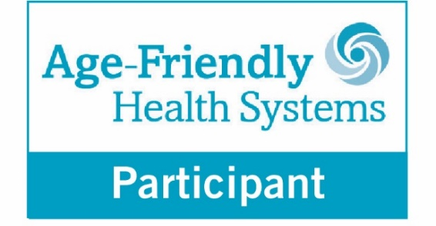
This badge is meant to be used by organizations who have submitted their 4Ms Care Description and received confirmation from IHI that they have been accepted as an Age-Friendly Health Systems Participant. Check the email with your recognition letter or visit the Participant website landing page for a high-quality copy of the badge.
We hope that you will proudly display this badge in your care settings and materials.
When your site of care has demonstrated a commitment to care excellence by having: (1) an accepted description; and (2) three consecutive monthly counts of older adults receiving your accepted description of 4Ms Care, you will receive the Age-Friendly Health Systems — Committed to Care Excellence badge.
Below are a few suggestions for displaying the badge:
Promote your participation in the movement on social media with the badge. Please use the hashtag #AgeFriendly.
Add the badge to your communications (newsletters, presentations, website, email, etc.).
You can direct people to www.ihi.org/AgeFriendly to learn more.
Post the badge in your care setting to signal your participation in the movement.

Use the Logo
Visit the Participant website landing page to download a high-quality copy of the Age-Friendly Health Systems logo. Use it to distinguish materials you create to promote age-friendly care.
Please refrain from using other logos for Age-Friendly Health Systems materials (for example, logos belonging to an individual founding partner of the movement, such as IHI).

Celebrate with Your Team
Host regular meetings across the organization to provide updates on age-friendly efforts and, recognize achievements. You might combine these with existing meetings or host a dedicated quarterly or twice yearly event about age-friendly care.

Create items to recognize staff, such as:
- Age-Friendly Health Systems pins
- Age-Friendly Health Systems lanyards
- An engraved plaque to display on the unit recognizing the achievement of Level 1 (Participant) recognition
- Visit https://agefriendlyhealthsystems.ourproshop.com/ to order and purchase predesigned materials at cost

People you may invite include:
- Executive leadership
- Chief nursing officers
- Patient- and family-advisory council (PFAC)/resource council members
- Older adults with lived experience who are engaged with the organization (e.g., older adults who serve on quality improvement committees or past focus group members)
- Family caregivers who are engaged with the organization
- Volunteers (who often represent a wide range of community members)
- Anyone who has a stake in high-quality care for older adults and can help spread the word of your efforts within your community

Brand Guidelines
Language Matters
Why does the Age-Friendly Health Systems initiative have brand guidelines? Using consistent language whenever possible helps to:
- Spread the evidence-based elements of the 4Ms to support reliable, high-quality care

- Build connections and a common way of communicating across different organizations, care settings, communities, and geographic locations

- Grow the Age-Friendly Health Systems movement to improve care for all older adults
Thank you for taking the time to review this guidance.
Thank you for all you do to share your team’s achievements and learnings about providing age-friendly care. By growing the movement, we can improve care for all older adults.

Written Style
- Age-Friendly Health Systems (capitalized) is an “initiative” or “movement” (not capitalized) as opposed to a project, program, etc.
- 4Ms Framework for Age-Friendly Care or 4Ms Framework is the focus of the initiative.
- Always hyphenate “Age-Friendly.” Capitalize references to the initiative, such as “Age-Friendly Health Systems.” Lowercase is fine for descriptions: “providing age-friendly care.”
- Limit the use of an acronym. When needed, use “AFHS.”
- On first mention, please spell out the entire name of the initiative. On second and later mentions, please use “the initiative” or “the Age-Friendly initiative.” If needed, use “AFHS.”
- “Systems” is plural when referring to the initiative. When separately speaking about one health system that has followed the 4Ms Framework, that entity may be referred to as an Age-Friendly Health System — singular and without initial caps.
- Use “clinician(s)” instead of “provider(s).”

Descriptive Statement
When describing the national initiative, use the following language:
Age-Friendly Health Systems is an initiative of The John A. Hartford Foundation and the Institute for Healthcare Improvement (IHI) in partnership with the American Hospital Association (AHA) and the Catholic Health Association of the United States (CHA).

4MS Framework
4Ms Framework for Age-Friendly Care or 4Ms Framework — initial caps, no space or apostrophe in 4Ms.
4Ms used without the word “framework” refers to the four elements. The 4Ms are “elements” or “essential elements” and not dimensions, components, aspects, etc.
For consistency, use these element descriptions and ALWAYS list the elements in this order:
- What Matters
- Medication
- Mentation*
- Mobility
*For communication with community members (older adults, caregivers, partner organizations), you may use “Mind” in place of “Mentation.” As an example, see My Health Checklist, a guide designed to be shared with older adults before health care conversations or appointments to help prepare.
The 4Ms graphic below can be downloaded on www.ihi.org/AgeFriendly and used for related work. The graphics may be used in their entirety without requesting permission.

