A Quality Improvement Grant Request for Proposals (RFP) Facilitating an Action Community in Support of Age- Friendly Care

A grant opportunity for organizations to facilitate an Action Community of health care organizations to improve care for older adults as part of the Age-Friendly Health Systems movement.

July 2021

I. Background
Age-Friendly Health Systems Movement
The United States is aging and the number of older adults, individuals ages 65 years and older, is growing rapidly. As we age, care often becomes more complex. Health systems are frequently unprepared for this complexity, and older adults suffer a disproportionate amount of harm while in the care of the health system.
To address these challenges, in 2017, The John A. Hartford Foundation (JAHF) and the Institute for Healthcare Improvement (IHI), in partnership with the American Hospital Association (AHA) and the Catholic Health Association of the United States (CHA), set a bold vision to build a social movement so that all care with older adults is age-friendly care. According to our definition, age-friendly care:
- Follows an essential set of evidence-based practices;
- Causes no harm; and
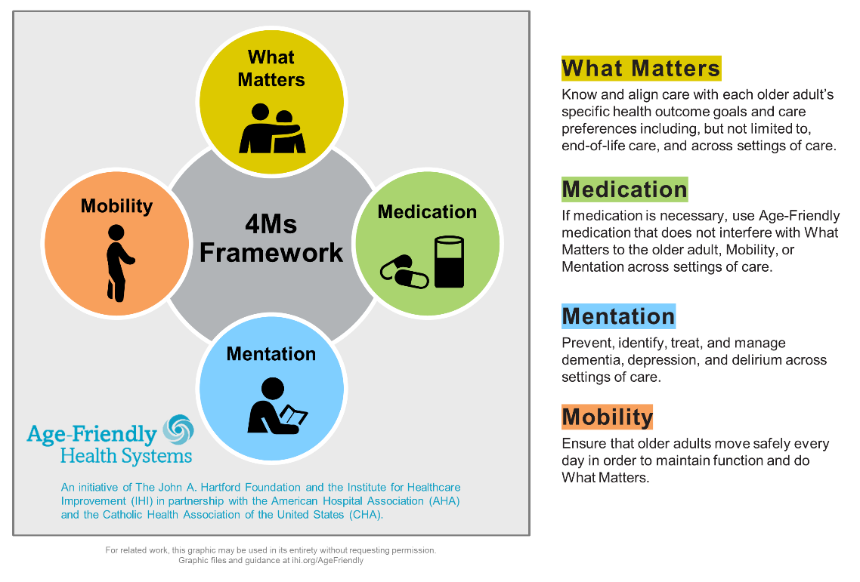
- Aligns with What Matters to the older adult and their family or other caregivers.
Becoming an Age-Friendly Health System entails reliably providing a set of four evidence-based elements of high-quality care, known as the “4Ms,” to all older adults in a health system. When implemented together, the 4Ms represent a broad shift by health systems to focus on the needs of older adults.
The 4Ms — What Matters, Medication, Mentation, and Mobility — make care of older adults that can be complex, more manageable. The 4Ms identify the core issues that should drive all care and decision making with the care of older adults. They organize care and focus on the older adult’s wellness and strengths rather than solely on disease. The 4Ms are relevant regardless of an older adult’s individual disease(s). They apply regardless of the number of functional problems an older adult may have, or that person’s cultural, ethnic, or religious background. The 4Ms are a framework, not a program, to guide all care of older adults wherever and whenever they touch health systems’ care and services. The intention is to incorporate the 4Ms into existing care, rather than layering them on top, to organize the efficient delivery of effective care.

II. RFP Intent
The intent of this RFP is to encourage organizations to submit proposals to facilitate an Action Community in service of expanding the number of older adults reached with Age-Friendly care/4Ms.
Age-Friendly Health System Action Communities
The Age-Friendly Health Systems movement now comprises thousands of hospitals, ambulatory practices, and nursing homes working to reliably deliver evidence-based care for older adults. IHI has a well-established track record, based on years of experience, of convening like-minded organizations to rapidly scale-up solutions to vexing problems in health care. That learning has informed the design of Action Communities. In an Age-Friendly Health Systems Action Community, up to 150 participating teams work together, mostly virtually, to test and rapidly scale-up specific 4M changes over a seven-month period. The Action Community is designed for hospital-based teams (e.g., emergency departments, ICUs, general wards, medical-surgical units), ambulatory care teams (e.g., primary care, specialty care), and nursing home teams (e.g., post-acute and long-term care communities). Action Communities are considered “on-ramps” for health care organizations to begin or accelerate their efforts towards becoming an Age-Friendly Health System. IHI has developed template resources and is available to support Action Community Facilitators in running an Action Community. Since 2018, IHI and its partners have launched more than 10 Action Communities to bring teams together to learn about and test the 4Ms. Action Community Facilitators are encouraged to adapt the Action Community design to best meet the needs of the network of health systems they will engage.
We are seeking organizations that are interested in facilitating an Action Community to spread Age-Friendly care through a competitive proposal process.
III. Eligibility

Geographic Scope: | United States and Territories
Applicant Eligibility Criteria: | - Only organizations are eligible to receive grants, not individuals or medical practice groups.  - Organizations who facilitate an Action Community may include those working to increase Age-Friendly care within a specific state or region, population of focus, or specific type of care facility.  - Preference will be given to organizations that demonstrate a commitment to serving the following sub-populations of older adults and that represent the following health systems of focus:  Focal populations of older adults  - Veterans  - Rural health populations  - Tribal health/indigenous groups  - Currently and formerly incarcerated  - LGBTQIA  - Black, Indigenous, Latinx, and additional people of color (BILPOC)  Focal health systems  - Community / Federally Qualified Health Centers  - Specialties (oncology, surgery, emergency medicine, behavioral health)  - Collaborate with IHI on the design and implementation of the Action Community  - Host a 7-month community to support organizations in achieving Age- Friendly Care recognition:  - Recruit organizations to participate  - Facilitate call series, including 1-2 recruitment calls, 5-6 monthly calls, and at least one deep- dive session, using a virtual platform with the intention of creating an all-teach, all learn environment  - Support external content experts when additional expertise is needed  - Integrate equity in the design and implementation  - Collaborate across other Action Community Facilitators to learn and improve the execution of Action Community facilitation across the movement.  - Co-design an Action Community that fits the needs of your movement’s stakeholders and the broader Age Friendly Health Systems movement the Action Community work to fit the needs of your community.  - Have an Executive Sponsor (C-suite level) within the organization who is enthusiastic about Age Friendly Care, 1-3 dedicated Project Manager(s) or Day-to-Day Leader(s) and any additional implementation staff that may be needed, faculty members/ improvement advisors with experience in facilitation and expertise with some or all of the 4Ms,  - Execution of the 4Ms will require a strong project management team that is able to collaborate alongside participating health systems and iterate on historic learnings.  - Create additional content and foster learning environments to support teams through their Age-Friendly journey, including but not limited to:  - Opportunities for peer learning  - Specialized content for leaders and sponsors of Age-Friendly initiatives  - Understand and ensure teams are aware of the opportunity for and are on a path towards recognition and connecting to IHI supports as necessary

IV. Requirements
Date RFP Issued: | July 12, 2021
Clinical Area: | Any health care setting that serves adults 65 and older, including but not limited to hospitals, practices, and post-acute long-term care
Specific Area of Interest for this RFP: | AFHS Action Community Aim:  IHI and JAHF are seeking to co-design an Action Community to support organizations in integrating the 4Ms in their care setting. An Action Community is a network of teams from across different health systems who come together to accelerate their own adoption of the 4Ms. Guided by expert faculty and an “all teach, all learn model,” teams participate on monthly webinars, attend convenings, and test specific changes to improve care for older adults. The Action Community is designed as an on-ramp for hospital-based teams (e.g., emergency departments, intensive care units, general wards, medical-surgical units), ambulatory care teams (e.g., primary care, specialty care), and nursing home teams (e.g., post-acute and long-term care) to test and adopt age-friendly care.  Implementation Areas of Focus & Programmatic Work:  Action Community implementation is focused in six domains of activity to onboard and support organizations in the integration of the 4Ms into their care environment, including:  - Co-design with IHI team: This includes collaborating with IHI in the design of the Action Community to best serve your population’s size and needs. Through the co-design process, it may be necessary to adapt the structure, standard content, funding, etc. to support participating teams in integrating the 4Ms in their care environment. Additionally, this includes regular meetings with the IHI team for the duration of the set-up and execution phase of the Action Community.  - Recruitment: This includes the promotion, networking, and responding to questions or concerns from Health Care Organizations that are interested in participating in upcoming Action Communities. Organizations that have facilitated Action Communities in the past have found informational calls an effective way to onboard organizations. Additionally, managing the enrollment process of teams including monitoring enrollee information.  - Supporting organizations in designing Age-Friendly Care and the 4Ms in their care setting: Through monthly calls, virtual long-form convenings, leadership/team engagement, and peer coaching, support teams in following the recommendations in the Guide to Using the 4Ms in the Care of Older Adults. This includes working with the IHI team to customize activities to best support you and the health settings with which you work.  - Commitment to Equity and Anti-racism: We recognize inequity as a result of how our economic, social, and health care systems are built. We work in inherently inequitable systems where not everyone has a fair and just opportunity for health. We see power dynamics consistently drive inequities due to historical and present-day inequities in access to resources and opportunity. It is our belief that health care was built as one of many systems that routinely advantages white people while producing cumulative and chronic adverse outcomes for people of color.  Health equity is more than having health outcomes that do not have statistically significant differences based on race. Our focus is that all people gain the access and power to build a healthy, joyous life with their communities and families. Our work includes narrowing equity gaps in health care as well as proactively creating the opportunity, environment, structures, accountability, and relationships that intentionally promote equity and the conditions for thriving.  Participation includes a strong understanding of equity and inequity within your organization and implementation setting(s) and continual learning, implementing, and iterating on change ideas to improve equity across all settings.  - Identification of Bright Spots: This includes highlighting teams who make rapid progress in the implementation of the 4Ms and whose story may be beneficial for other organizations to learn from through a cases study or presentation in another Action Community.  Action Community Facilitator applicants will share about the organizations they hope to engage in this work in addition to how grant funding will be leveraged to support age-friendly care. Applications will describe how previous work is in alignment and conducive to the components listed above and/or will include steps to bridge any implementation gaps. Successful applicants, once chosen, will iterate on these materials alongside the IHI team, establishing an implementation plan in preparation for their work.  Each Action Community Facilitator will be supported through standard materials that have been utilized in previous Action Communities. Connection and collaboration with the IHI team, introductions to interested faculty members and organizations who have completed work in alignment with the 4Ms, and connections to other Action Community Facilitators currently doing this work. IHI will support your organization in supporting teams with implementation, sustainability, and scale-up, as needed.
Expected Approximate Monetary Range of Grant Applications: | Applications requesting grant support up to $300,000 will be considered with priority given to proposals between $100,000-$200,000. Applicants might consider seeking support from other interested funders or leveraging in kind support.
Key Dates: | - RFP release date: July 12, 2021  - Proposal deadline: October 1, 2021.  - Review of proposals by external review panel: October 15, 2021  - Anticipated notification date: October 22, 2021  - Anticipated initiative start and end dates: November 5, 2021 to November 4, 2022 inclusive of set up and recruitment phases, however start dates will be developed alongside supported teams for a duration of one year.
How to Submit: | Please email completed proposals to IHI Project Manager, Chelsea Canedy at ccaendy@IHI.org and include Action Community RFP in the subject line.
Questions: | - If you have questions regarding this RFP, please direct them in writing to the IHI Project Manager, Chelsea Canedy at ccaendy@IHI.org and include Action Community RFP in the subject line. Any general questions about the Age-Friendly movement can be directed to afhs@ihi.org.
Grant Agreements: | - If your grant is approved, your institution will be required to enter into a written grant agreement with IHI.  - IHI has drafted the terms of these agreements to be balanced and reasonable and to further the goals of both parties. Negotiating grant agreements requires significant resources, so please ensure that your institution (including your legal department) is able and willing to abide by these terms before proceeding with submission of your application as they will need to be accepted in their entirety.
Review and Approval Process: | - An expert review panel (ERP) will make final grant decisions.  - The panel comprises professionals from the medical community with expertise in clinical areas related to Age-Friendly care and quality improvement methods.
Mechanism by Which Applicants will be Notified: | - All applicants will be notified via email by the October 22nd 2021 unless otherwise stated  - Applicants may be asked for additional clarification during the review period.

Appendix A
Action Community Facilitation Proposal
Applications will be accepted via email. Proposal documents should be no longer than 8 pages in length (12-point font and 1-inch margins) excluding Organization Detail and References. When uploading your proposal please ensure it addresses the following*:
Organization Information: | Please describe your organization, including:  - Key Contact  - Organization type  - City and State  - Mission and vision  - Population(s) served
Action Community Recruitment: | Please describe the organizations you expect to recruit into the Action Community:  - Organization type(s), including care setting(s)  - Population(s) served  - Recruitment goal (number of organizations)  Please describe the methods you will use to recruit teams into the Action Community.
Organizational Capacity to Lead an Action Community: | Please describe the resources and infrastructure available to contribute to successful Action Community facilitation.  - Access to experts (quality improvement and 4Ms care)  - Executive sponsorship  - Project management staff  - Infrastructure (i.e. webinar capability)  - Include a current inventory of your resources, initiatives, public commitments, and investments related to improving the care of older adults (aged 65+)  - Describe the ways your organization has demonstrated a commitment to equity and reducing/eliminating equity gaps?
Evaluation and Outcomes: | - Quantify the amount of change/impact expected from this initiative in terms of your target audience.  - Describe how the lessons from the initiative outcomes will be used and/or disseminated within your network.
Additional Information: | If there is any additional information you feel IHI should be aware of concerning the importance of this initiative, please summarize here.
Budget Detail: | - Please include a budget narrative that describes in greater detail the line items specified in the budget submitted within the application.  - The budget amount requested must be in U.S. dollars (USD).  - While estimating your budget please keep the following items in mind:  - Institutional overhead and indirect costs may be included within the grant request. Examples include human resources department costs, payroll processing and accounting costs, janitorial services, utilities, property taxes, property and liability insurance, and building maintenance as well as additional project expenses such as costs for publication, IRB / IEC review fees, software license fees, and travel. Please note: IHI does not provide funding for capital equipment.  - The inclusion of these costs cannot cause the amount requested to exceed the budget limit set forth in the RFP.

