

1. Category of Submission

I am submitting and abstract that features (select the most appropriate category):
Methods (presentations to build knowledge on the use of a particular method, or tool related to improvement science or related disciplines) ☐
Results from an Improvement Initiative (presentations showing how an outcome was achieved (and/or other learning) through the use of improvement methods and tools) ☐
A case study from the field: ☐

Abstracts in the first two categories will be eligible for consideration for publication in a special issue of BMJ Open Quality

2. Main Submission Details

Presentation Title (100 Characters including spaces): * Title should be descriptive and engaging, avoiding acronyms and exclamation points. Please limit the presentation title to 100 characters, including spaces.
Click or tap here to enter text.
Subject Matter Focus – Please Select One (descriptions below) *
AI in Health Care: Hype, Reality & What’s Next: ☐
Chief Quality Officers: Leading System-Wide Impact: ☐
Health Equity: ☐
Improvement Science & Methods ☐
Leadership: ☐
Patient and Workforce Safety: ☐
Population Health: ☐
ROI of Leading with Quality in Health Care: ☐
Workforce Well-Being: ☐

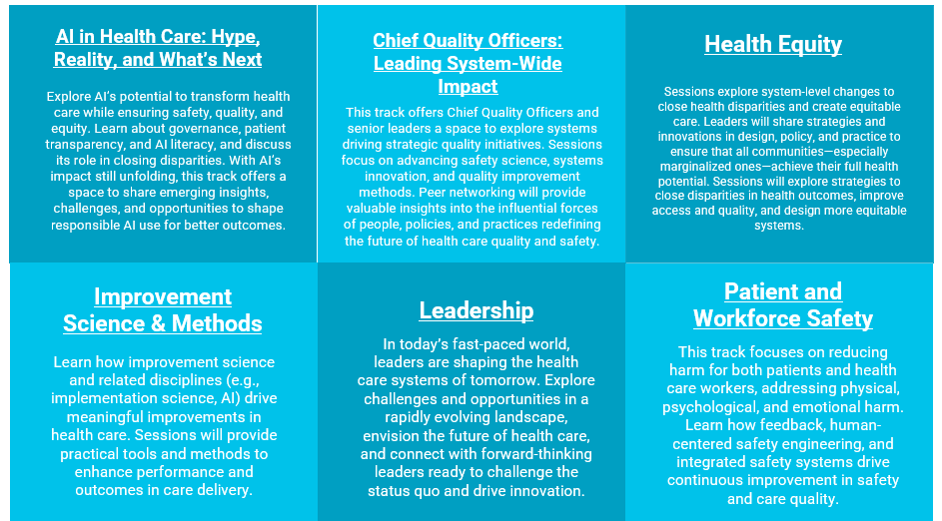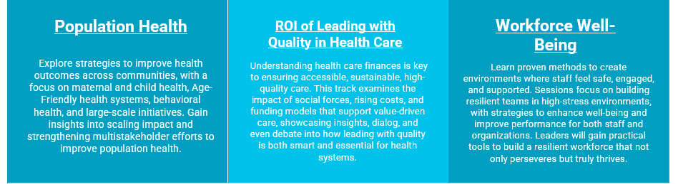
Does your submission fit under any other subject matters? *
Yes: ☐ (If yes, please mark one to two additional subject matters below)
No: ☐
AI in Health Care: Hype, Reality & What’s Next: ☐
Chief Quality Officers: Leading System-Wide Impact: ☐
Health Equity: ☐
Improvement Science & Methods ☐
Leadership: ☐
Patient and Workforce Safety: ☐
Population Health: ☐
ROI of Leading with Quality in Health Care: ☐
Workforce Well-Being: ☐

[if you selected Patient and Workforce Safety above]
Does your proposal include content on improving excellence in diagnostic safety? *
Yes: ☐
No: ☐

Does your submission include patient and family centered care content? *
Yes: ☐
No: ☐

Population Focus – Please Select One *
All Populations: ☐
Communities of Color: ☐
Individuals disproportionately affected by inequities: ☐
Individuals/patients at the end of life: ☐
Individuals/patients with chronic conditions: ☐
Individuals/patients with complex health or care needs: ☐
Individuals/patients with mental health and/or substance use disorders: ☐
Infants and/or children: ☐
LGBTQIA+: ☐
Infants and/or children: ☐
Migrant/Immigrant and Incarcerated Populations: ☐
Military/Veteran: ☐
Mothers/Birthing Persons and/or Newborns: ☐
Older Adults ☐
Population Segments by Payor: ☐
Populations in Rural Areas: ☐
Specific Geographic/Community Populations: ☐
Teens and/or Young Adults: ☐
Subtopic Area – Please Select 1-3 *
Based on the main subject matter area you selected, you will need to select subtopic areas that will help the IHI Forum committee review your proposal in further detail. There are a large variety of subtopic areas which can be found in the online application.

[Subtopics can be found in the submission form as there are too many to list]
Attendee Experience Level – Please Select One *
To help guide our attendees in choosing which sessions they would like to join, we ask that you choose a difficulty level for your session. Please see the levels below.
Student: Offers a wide range of topics and disciplines that are especially appropriate for students who are new to quality improvement or the IHI Forum. ☐
Novice: Helpful ideas and tools for newcomers to the world of quality improvement. No significant QI knowledge is assumed. ☐
Intermediate: Attendees with a sound knowledge of quality improvement methodology. Presenters will assume attendees have at
least some experience or knowledge in QI. ☐
Advanced: Advanced learner and will provide cutting-edge quality improvement thinking. ☐
All Levels: Suitable for anyone from QI beginner to expert: ☐
3. Session Format

Which format of session are you submitting for – Please Select One: *
Half-Day Pre-Conference Workshop: 3 hours (including breaks for participants): ☐
Focus-topic "how to" learning sessions that allow participants to fully engage in discussions and Q&A with world-renowned experts. Attendees will take home new tools, implement quality improvement practices, and gain and sustain success.
General Session: 60 minutes ☐
Can involve a variety of formats, either didactic or interactive.
Rise and Shine Session: 45 Minutes ☐
Slightly shorter popular early morning sessions that kick off each day's content. Mostly didactic in nature, with partial attendee interaction. Attendees bring their coffee/breakfast and are looking for an exciting way to start the day.
Couch Conversations: 30 Minutes ☐
These intimate sessions of 30 people or less are entirely conversational in nature. They take place in a circular seating arrangement without use of a screen and presentation file, only relying upon the conversation between presenter and attendees.
Abstract-Driven Session:12 Minutes ☐
Mostly didactic in nature, with partial attendee interaction. Each abstract presenter will have around 12 minutes to present and a moderator will facilitate a discussion with attendees and other abstract presenters (~4 abstracts per 60-minute session)
Pecha Kucha: 6 Minutes, 40 Seconds ☐
Pecha Kucha is a presentation method that calls for telling a story using images rather than reading text on slides. These presentations use 20 slides, programmed to auto advance at 20 seconds. With 20 slides at 20 seconds each slide, the presentation will total at 6 minutes and 40 seconds. In these sessions several teams/individuals will share their work rapid-fire style.

[if you selected Half-Day Workshop, General Session, Rise & Shine, or Couch Conversation] *
Please describe how you might structure the session, as well as a description of the tool / method / framework or relevant data/results you will be highlighting.
Click or tap here to enter text.
Alternative Formats
Attendees are increasingly looking for more interactive session formats to keep them engaged. An alternative format refers to a unique method of learning for the attendees.
Methods that do NOT count as alternative: Polling, Q&A, Storytelling
A percentage of the final Forum program will be made entirely up of these alternative session formats. We highly encourage submissions to employ other formats than the common one-way slide deck presentation to increase their chances at acceptance.
Examples of alternative formats: Campfire, Flipped Classroom, World Cafe, Role-Playing, Debate, Fishbowl, Pecha Kucha, Roundtable, Jigsaw, Notes Day, Simulation, Stand-Up Comedy, Talent Show, Table Group Activities as a significant % of the session, etc.
Does your session employ a newer type of learning format? *
Yes: ☐
No: ☐
[if you selected Yes above, please name the learning format] *
Click or tap here to enter text.
Should you be accepted, you are agreeing to utilize this alternative format in your final presentation. Permitting only slight modifications, any removal of your alternative format in lieu of a standard slide deck presentation will result in an immediate removal of your presentation from the program regardless of proximity to the conference date. *
I understand and agree: ☐
4. Session Objectives & Description

Learner Objectives (100 Characters including spaces each) *
[Half-Day Workshops, General Sessions, Couch Conversations, & Rise and Shine Sessions] Please list TWO to THREE action-oriented SMART objectives.
[Abstract-Driven Sessions, Pecha Kucha] Please list ONE action-oriented SMART objectives.
Please list action-oriented SMART objectives of what attendees should be able to do after attending your session. Objectives should be measurable.
To be in compliance with accreditation guidelines the following verbs are NOT accepted: Know, Comprehend, Understand, Appreciate, Familiarize, Study, Be Aware, Become Acquainted with, Gain Knowledge of, Cover, Learn, Realize.
Helpful Resources:
Utilize the objective build tool for a list of suitable verbs: Objective Builder
Objective 1: * Click or tap here to enter text.
Objective 2: * Click or tap here to enter text.
Objective 3: * Click or tap here to enter text.

5. Session Description

4a. Submission Description for Scientific Abstracts (1350 character limit including spaces) *
[For submissions that selected “Methods” or “Results from Improvement Initiative” in the first question]
Enter the body of your description below. The summary must contain these 5 sections:
- Background (what is the need):
- Objectives:
- Methods:
- Results (if applicable):
- Conclusion & Implications:
See the Guidance for Writing Abstracts and Review Criteria sections in the submission portal for helpful tips in writing your description to boost your chances of success.
Description:
Click or tap here to enter text.
4b. Submission Description for Case Studies (1350 character limit including spaces) *
[For submissions that selected “Case Study” in the first question]

Enter the body of your description below. The summary must contain these 5 sections:
- Introduction:
- Problem or Challenge:
- Strategy or Experience:
- Findings:
- Conclusion:
Description:
Click or tap here to enter text.
6. Frameworks and Attachments

Attachments
- As we can only glean certain information from your session description, we STRONLY encourage you to submit an attachment that displays the results of your work or any additional supplementary information and/or data. This additional information will boost your chances of acceptance.
You may choose to upload a single file. The file MUST contain a maximum of 5 tables/figures (combined). Files containing more than 5 tables/figures will not be considered.
Further considerations for attachments:
    - We will look for time-ordered data (e.g., run charts, control charts, time series analysis).
    - We do not accept pie charts or bar graphs.
    - Please make sure all documents/images are high quality and easy to read.
    - Tables and figures should be clearly numbered and cited in the proposal.
    - Table/figure captions should be provided as editable text.
[You can upload one document per the following categories in the form: Supplementary Info, Case Study Results, Methods/Tools/Framework]

7. Presenters

Presenter Information *
IHI has a limit of 4 presenters per session. For abstract-driven and pecha kucha sessions we recommend a maximum of 1 to 2 presenters given the presentation time. Please consider this limit when planning out the content and structure for your presentation. All additional presenter information must be added including their bio. Presenter photos are welcome but not mandatory.
- First and Last Name
- Email Address
- Job Title
- Organization
- Credentials (if applicable)
- Short Biography (maximum of 750 characters)

Presenter 1: * Click or tap here to enter text.
Presenter 2: Click or tap here to enter text.
Presenter 3: Click or tap here to enter text.
Presenter 4: Click or tap here to enter text.
Additional Contacts
If accepted, are there others/assistants you would like to cc on all future communications? If so please enter their name(s) and email(s) below.
Click or tap here to enter text.
Waived Registrations *
- Half-Day Workshops
    - A maximum of 2 speaking presenters per session are eligible to have their entire conference fees waived (includes all days December 7-10).
- General Sessions, Rise and Shine Sessions, Couch Conversations
    - A maximum of 2 speaking presenters per session are eligible to have their General Conference (December 9 & 10) registration fees waived.
- Couch Conversations, Pecha Kucha, Abstract-Driven Sessions
    - A maximum of 1 speaking presenter per session is eligible to have their General Conference (December 9 & 10) registration fees waived.
*Should the people receiving these benefits change between now and when the waived registration links go after acceptance, please notify us at presentations@ihi.org.*
Presenter Names to Receive Complimentary Registration*
Click or tap here to enter text.

8. Planning Team
The IHI Forum is looking for sessions that encompass a wide variety of disciplines. We are now giving higher acceptance priority to submissions that include a nurse, physician or pharmacist planner. We aim to offer continuing education credits to our attendees and the attendees in turn are more likely to attend sessions that offer CE credits. Not including these planners does not mean your submission will be rejected, it will mean it is not approved for these credits.
In support of improving patient care, the Institute for Healthcare Improvement is jointly accredited by the Accreditation Council for Continuing Medical Education (ACCME), the Accreditation Council for Pharmacy Education (ACPE), and the American Nurses Credentialing Center (ANCC), to provide continuing education for the healthcare team. IHI offers continuing education credits for a variety of disciplines. In order for your session to be approved for physician, nursing, and/or pharmacy continuing education credits, you must complete the table below.
A planner is defined as a licensed professional who is meaningfully involved in developing, implementing, and evaluating session content. Simply serving as a presenter does not qualify as meaningful involvement.
All planners must also complete a disclosure.
Did you have a Nurse planner(s) involved in the planning of your session for the IHI Forum? *
Yes: ☐
No: ☐

If yes…..
- Describe how the licensed Nurse was involved in the planning:* Click or tap here to enter text.
- Full Name (Nurse Planner):* Click or tap here to enter text.
- Credentials:* Click or tap here to enter text.
- Job Title:* Click or tap here to enter text.
- Organization:* Click or tap here to enter text.
- Email Address:* Click or tap here to enter text.
- Brief Biography (1-2 paragraphs):* Click or tap here to enter text.

Did you have a Physician planner(s) involved in the planning of your session for the IHI Forum? *
Yes: ☐
No: ☐
If yes…..
- Describe how the licensed Physician was involved in the planning:* Click or tap here to enter text.
- Full Name (Physician Planner):* Click or tap here to enter text.
- Credentials:* Click or tap here to enter text.
- Job Title:* Click or tap here to enter text.
- Organization:* Click or tap here to enter text.
- Email Address:* Click or tap here to enter text.
- Brief Biography (1-2 paragraphs):* Click or tap here to enter text.
Did you have a Pharmacist planner(s) involved in the planning of your session for the IHI Forum? *
Yes: ☐
No: ☐

If yes…..
- Describe how the licensed Pharmacist was involved in the planning: * Click or tap here to enter text.
- Full Name (Pharmacist Planner): * Click or tap here to enter text.
- Credentials: * Click or tap here to enter text.
- Job Title: * Click or tap here to enter text.
- Organization: * Click or tap here to enter text.
- Email Address: * Click or tap here to enter text.
- Brief Biography (1-2 paragraphs): * Click or tap here to enter text.

Did you have a Patient and Family Advocate involved in the planning of your session for the IHI Forum? *
Yes: ☐
No: ☐

If yes…..
- Describe how the advocate was involved in the planning: * Click or tap here to enter text.
- Full Name (Patient and Family Advocate Planner): * Click or tap here to enter text.
- Credentials: * Click or tap here to enter text.
- Job Title: * Click or tap here to enter text.
- Organization: * Click or tap here to enter text.
- Email Address: * Click or tap here to enter text.
- Brief Biography (1-2 paragraphs): * Click or tap here to enter text.

9. Mandatory Presenter & Planner Disclosures
To be considered for acceptance into the Forum, ALL SPEAKING PRESENTERS and PLANNERS listed above must complete the disclosure form via the instructions below prior to May 30. Failure to fill out a disclosure for each presenter in your submission will result in dismissal from consideration.

Please send the instructions and the link below to your fellow presenters and planners so that they can complete their disclosures. If you are submitting multiple abstracts you do not need to fill out a disclosure for yourself for each abstract.

Disclosure instructions: *
Visit IHI.org to login to your IHI account (or create one via the link below if needed).
Create IHI Account Here
Once you’re logged into your account, go to my.ihi.org/Disclosure to complete the IHI Disclosure Form.
Disclosure Form Clarifications
Title of Continuing Education Activity - Please enter "Forum - (Title of your submission)"
Location of Continuing Education Activity - Please enter "Forum"
Start & End Date of Continuing Education Activity - Please enter "December 7-10"
Key Presenter Disclosure
In addition to the disclosures completed above, we ask that you please give an overall disclosure for the group so that when we are reviewing the proposals we have a brief idea of any additional information we should know.
Does the speaker disclose any relevant financial or nonfinancial relationship(s) with any individual or organization that provides goods and services related to IHI’s business and/or the nature of the presentation? This includes anything of monetary value, including but not limited to salary, other payments for services (e.g. consulting fees or honoraria) and equity interest. A conflict may exist where an interested party and his/her immediate spouse/significant other, or a business associate of an interested party, directly or indirectly benefits or profits as a result of a decision made, or a transaction entered into, by IHI. *
Yes: ☐
No: ☐
[If yes to the above: please complete any of the applicable options below for all actual, potential or perceived conflicts of interest.] *
- Salary:
Yes: ☐
No: ☐
- Royalty:
Yes: ☐
No: ☐
- Stock:
Yes: ☐
No: ☐
- Speakers Bureau:
Yes: ☐
No: ☐
- Consultant:
Yes: ☐
No: ☐
- Other:
Yes: ☐
No: ☐
[If yes to any of the above, please describe]: *
Click or tap here to enter text.
Will the presentation include any off-label or investigational uses? *
Yes: ☐
No: ☐
[If yes to the above, please describe]: *
Click or tap here to enter text.
Will the presentation include discussion of any commercial products or services, including consulting services? *
Yes: ☐
No: ☐
[If yes to the above, do they appear to have a relevant financial relationship or interest or nonfinancial relationship with the manufacturer(s) or distributor(s) of any of the products or provider(s) of any of the services that they intend to discuss] *
Yes: ☐
No: ☐

10. BMJ Publication

[This section is only required if you select the “Results from an improvement initiative and/or a methods-focused presentation related to the sciences of improvement” option in the first question at the beginning of the form]
Abstracts in the category of "Results from an Improvement Initiative and/or a Methods-Focused presentation related to the Sciences of Improvement" are eligible for consideration for publication in a special issue of BMJ Open Quality. You are not required to be published if accepted.

Can we make the submitter’s email contact public to attendees of the conference? (Your reply as the submitter will pertain to all presenters and authors listed above.) *
Yes, all authors: ☐
Yes, lead author only: ☐
No: ☐

Top-rated abstracts will be published, with author consent, in BMJ Open Quality. Authors of all published proposals are required to grant an exclusive license to BMJ. The coordinator is responsible for ensuring corresponding/lead authors agree to the terms and conditions of BMJ’s standard license to publish for abstracts. Do you consent to the above? Your answer does not affect acceptance to the Forum, just consideration for abstract publication. *
Yes: ☐
No: ☐

Have you previously presented this work at the IHI Forum? *
Yes: ☐
No: ☐

[If yes to the above, please state year]: *
Click or tap here to enter text.

Have you presented this work at any other conference or published it in a journal (including published, accepted, or currently under review)? *
Yes: ☐
No: ☐
[If yes to the above, please provide details]: *
Click or tap here to enter text.

11. Posters

If I am not selected for a speaking session, I wish to be considered for a poster. Poster submissions are limited to 1 per person. If you have submitted more than one session proposal, IHI will give you the opportunity to select the proposal you wish to submit as your final poster submission. *
Yes, consider me for a Poster: ☐
Do not consider me for a Poster: ☐

Thank you for your interest in submitting to the IHI Forum! We aim to have acceptance notifications go out by the end of July at the latest. If you have any questions in the meantime while you wait please refer to the "Frequently Asked Questions" tab for more information or reach out to us at presentations@ihi.org. Thank you again!

