- Main Submission Details

Presentation Title (100 Characters including spaces): * Title should be descriptive and engaging, avoiding acronyms and exclamation points. Please limit the presentation title to 100 characters, including spaces.
Click or tap here to enter text.

Subject Matter Focus – Please Select One (descriptions below) *
Culture, Leadership and Governance: ☐
Learning Systems: ☐
Patient and Family Engagement: ☐
Workforce Safety and Well-Being: ☐

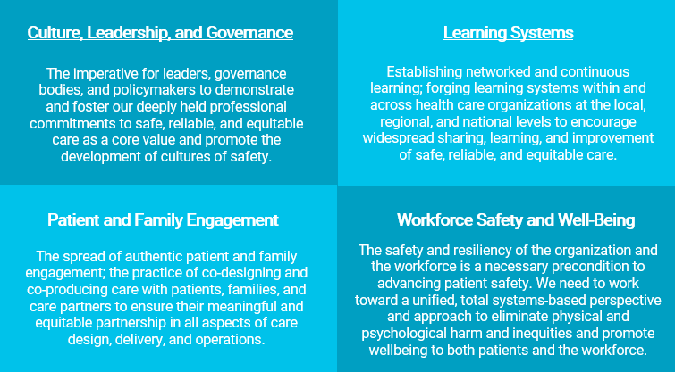

- Submission Description
Summary of Poster (300 Word limit) *
The summary will need to be 300 words or less. Please review it for accuracy before submitting.

You are required to include the following information:
- Description of the Problem or Purpose
- Actions Taken
- Summary of Results
- Lessons Learned
Click or tap here to enter text.

- Poster PDF

Attachments
Poster submissions require a completed version of your poster uploaded in PDF form. You can upload your PDF in the submission portal. The requirements for this can be found on the poster guidelines section located here. No specific format is needed for the poster file besides fitting on one page. The maximum file size for the PDF is 10MB.

- Presenters

Presenter Information *
Only the people who will be at the conference speaking to the poster need to have their information listed in the submission form. All other contributors to the work can be listed on the poster if you like.

For each presenter you will need to prepare the following fields to be entered into the online form.

First Name
Last Name
Credentials (if applicable)
Email Address
Job Title
Company
Short Bio (maximum 750 characters including spaces)

Poster Presenter Information: * Click or tap here to enter text.

